Characterization of LUSI Mud of Mud Volcano as Geopolymer Raw Material
- M. Mustafa Al Bakri¹, A. R. Rafiza¹, D. Hardjito², H. Kamarudin¹, and I. Khairul Nizar³
¹Center of Excellence Geopolymer System Research, School of Material Engineering,Universiti Malaysia Perlis (UniMAP), 01000, P.O. Box 77, D/A PejabatPosBesar,Kangar, Perlis, Malaysia
² Civil Engineering Department, Petra Christian University, Jalan Siwalankerto 121-131, Surabaya 60236 Indonesia
³School of Environmental Engineering,Universiti Malaysia Perlis (UniMAP), 01000, P.O. Box 77, D/A PejabatPosBesar,Kangar, Perlis, Malaysia

Abstract. The mud of mud volcano samples were collected from an eruption site named ‘LUSI’ (Lumpur “mud” –Sidoarjo), East Java, Indonesia for characterization. Analysis showed that, the major constituents of mud volcano are SiO₂ and Al₂O₃ which is are higher than those in fly ash. The particle of mud volcano has a flake-shaped particle and the overall particle size is dominated by particles between 2.5µm – 25.0µm. The results of XRD shows that mud of mud volcano have a characteristic of structurally disordered compounds, and a set of peaks corresponding to minor crystalline phases such as quartz, feldspars, and kaolinite. FTIR adsorption bands of the raw material of mud volcano has the chemical bonding between bands 1-5.

Keywords: geopolymer; XRF; XRD, FTIR; SEM.

Introduction
Mud volcano with an eruption site named ‘LUSI’ (Lumpur “mud” –Sidoarjo), East Java, Indonesia, has become a major issue since May 29, 2006 when it surfaced from the bowel of the earth and impacted an area of almost 770 hectare to a depth of 20 m, from 2007 and thirty thousand people have been displaced which cost Indonesia $3.7 billion in damages and damage control [1, 2]. This disaster has become a controversial debate. It was caused by the drilling of a deep gas exploration well and impacted from the Yogyakarta earthquake of May 27, 2006 with a magnitude of 6.3 [3].The mud volcano flows out continuously and it has covered 600 not less than 770 hectare of productive land and has completely immersed many villages [4]. Experts expect the eruption to continue for years [5]. LUSI has attracted researchers to conduct the scientific studies to examine its natural and to explore an alternative effort to minimize its volume by producing the mud volcano products.
The geopolymer technology developed by Davidovits offers an attractive solution regarding this issue [6, 7]. Furthermore, geopolymer development desires to reduce greenhouse gas emissions from the production of concrete products. Past researches have shown that the performance of geopolymer concrete produces high compressive strength and greater durability than ordinary concrete [8-10]. It is also well known that geopolymers possess excellent mechanical properties, as well as fire and acid resistance [11, 12]. The pozzolan materials such as fly ash, metakaolin, or ground granulated blast slag, induced by high-alkaline solutions, can be used as total replacement for ordinary cement (Portland cement) or totally binder to produce concrete instead of the ordinary cement paste [13-16].

The LUSI mud volcano has degree matrix elements similar to pozzolan chemical compositions. Its natural characteristic, that contains silica and alumina element, can be categorized as a cement replacement material [17]. The aim of this study is to establish the characteristics of LUSI mud of mud volcano from in East Java, Indonesia as a potential raw material for geopolymer composite.

Experimental
Raw Materials
The present study was conducted on the mud collected from around the eruption sites called the LUSI mud volcano near Sidoarjo, East Java, Indonesia. As of the fall of 2007, over 30 million m³ mud with temperatures ranging from 70-100°C had erupted, and the eruption continues until now (2012) and it is predicted to continue until 25 or more years. The mud volcano was collected directly from the eruption site. The material was transferred into sealed container. The mud was medium gray in colour.

Laboratory Methods
Composite mud volcano samples were collected and analyzed for different parameters. X-ray fluorescence (XRF) was used to measure the chemical composition of mud volcano. X-ray diffraction (XRD) patterns were performed and this test was held to investigate the phase analysis of the original mud volcano. Scanning electron microscopy (SEM) was performed to investigate the microstructure and shape of the original mud volcano. Fourier Transform Infrared Spectroscopy (FTIR) was performed to determine the bonding between the particles in original mud volcano. All samples were prepared in powder form for testing purpose.

Results and Discussion
Chemical composition of mud volcano
The chemical composition of LUSI mud volcano and fly ash as other pozzolanic material is shown in Table 1. The major constituents are SiO₂ with 38.5% and 26.4% for LUSI mud volcano and fly ash, respectively. The content of Al₂O₃ for both materials is 14.2% and 9.25%. This shows that the content of silica and alumina in raw material of LUSI mud volcano is higher than fly ash which is suitable to use as a raw material for geopolymer. However, the content of Fe₂O₃ for mud volcano is merely lower than fly ash. The composition of Ca in mud of mud volcano is significantly lower than fly ash. Others macro nutrients such as Ti, Mn and K for mud volcano is comparable to the fly ash.

Table 1: Major chemical composition of the collected LUSI mud volcano compared to fly ash.
Elements | Mud Volcano (LUSI, Surabaya, Indonesia)  % | Fly Ash (Power Station, Lumut, Perak, Malaysia)  %
Al₂O₃ | 14.2 | 9.25
SiO₂ | 38.5 | 26.4
K₂O | 4.31 | 2.58
TiO₂ | 1.76 | 3.07
Fe₂O₃ | 23.76 | 30.13
CaO | 5.62 | 21.6
MnO | 0.35 | 0.27
P₂O₅ | - | 0.67
SO₃ | 0.78 | 1.3
V₂O₅ | 0.067 | 0.13

SEM analysis of LUSI mud volcano
Scanning Electron Microscopy (SEM) analyses of the mud volcano compared to fly ash is shown in Fig. 1 (a) and (b). As seen in Fig. 1b, the particles of fly ash are spherically-shaped. However the particle of mud volcano (Fig. 1a) has a plate-like structure or flake-shaped particles similar to clay. The overall particle size of the LUSI mud of mud volcano sample is dominated by particles between 2.5µm – 25.0µm, meanwhile the particle size of fly ash is smaller than mud volcano particles with less than 10.0µm.

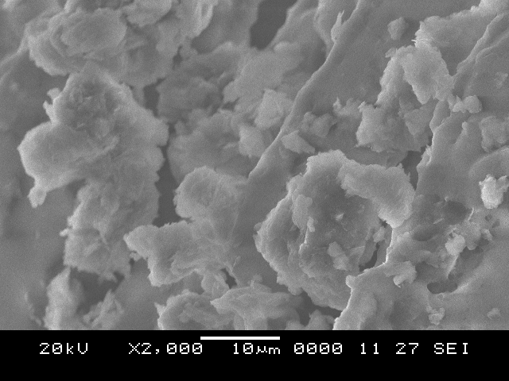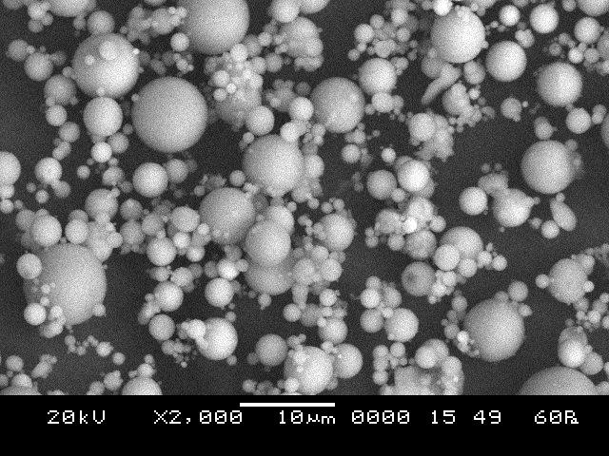
(b)
(a)
Fig. 1: SEM pictures of: (a) LUSI mud volcano; (b) fly ash.

XRD pattern
X-Ray diffraction (XRD) analyses of the mud volcano compared with fly ash are shown in Fig. 2. Both starting materials exhibit a peak at 2 thetha where 2 thetha = 20º - 32º, which is characteristic of structurally disordered compounds, and a set of peaks corresponding to minor crystalline phases, i.e., quartz and faujasite, and mullite in the case of fly ash [18], meanwhile quartz, feldspars, and kaolinite in the case of mud volcano. The peak at 2 thetha = 27° of mud volcano shows slightly towards higher than fly ash due to higher composition of SiO₂ in mud volcano compared to fly ash. Geoffrey S. [1] stated that the mud volcano also dominated by smectite, illite, and mixed illite/smectite, with lesser kaolinite and chlorite.
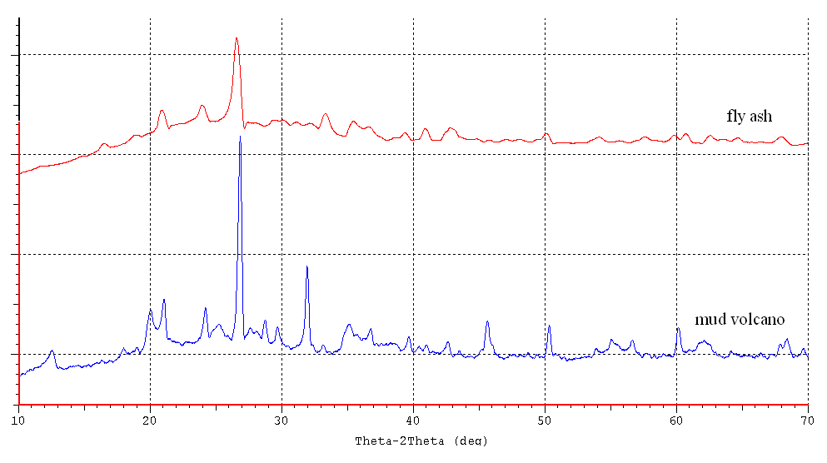
Fig. 2: X-ray diffraction patterns of raw materials: (a) fly ash and (b) mud volcano.

Fourier Transform Infrared Spectroscopy (FTIR)
Fig. 3 shows that the main FTIR adsorption bands of the raw materials of mud volcano compared to fly ash from bands 1-5. The peak at band 1 due to the vibrations of 1090 cm⁻¹ is due to asymmetrical stretching vibrations of Al-O/Si-O bonds, indicating the presence of Si and Al in the raw materials. As can be seen in Fig.3, the depth of the mud volcano peak at band 1 is higher than fly ash due to high composition of Si and Al in raw material mud volcano as shown in Table 1. The appearance of band 2 at 1410 cm⁻¹ assigned to the stretching vibration of O-C-O. Meanwhile, for Si-O/OH, a bending band occurs at band 3 at the vibrations of 880 cm⁻¹. The weak band seen between bands 4 and 5 characterizes the spectrum of stretching and deformation vibrations of OH and H-O-H groups from the weakly-bound water molecules, which are adsorbed on the surface or trapped in the large cavities between the rings of the geopolymeric products [19, 20].

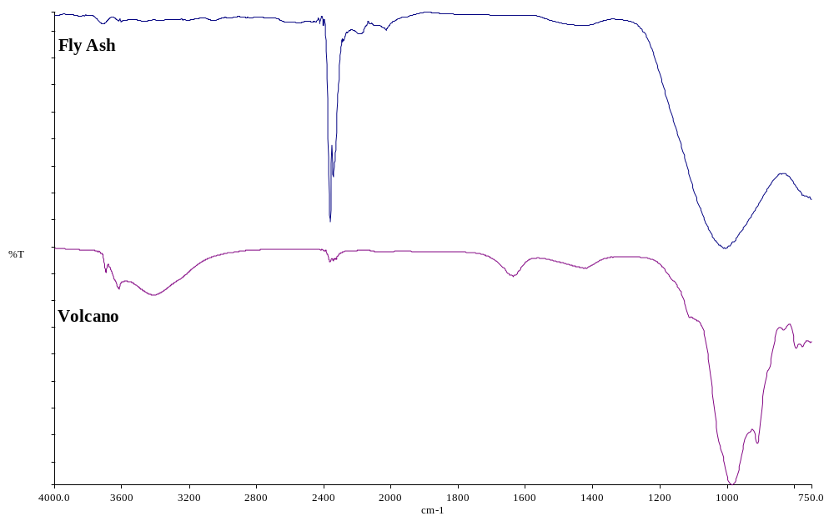
Band 3
Band 1
Band 2
Band 4
Band 5
Fig. 3: FTIR spectra of raw materials of LUSI mud volcano and fly ash.

Conclusion
Analysis was carried out to explore the characteristic of LUSI mud of mud volcano as the potential benefits of the unstoppable mud flow. The results show that the chemical composition of mud volcano has the major constituents of SiO₂ and Al₂O₃ which is 32% higher than fly ash. The particle of LUSI mud volcano has flake-shaped particles and the overall particle size is dominated by particles between 2.5µm - 25.0µm. XRD analysis shows the minor crystalline structure such as quartz, feldspars, and kaolinite. The FTIR peaks indicated the existence of Al-O/Si-O, O-C-O and Si-O/OH bonding in original mud volcano. Finding from this study shows that the LUSI mud of mud volcano has potential as a raw material in geopolymer system due to characteristic of mud volcano which is comparable to the fly ash.

References
1. Geoffrey S. Plumlee, T.J.C., Handoko T. Wibowo, Robert J. Rosenbauer, Craig A. Johnson, George N. Breit, Preliminary Analytical Results for a Mud Sample Collected from the LUSI Mud Volcano, Sidoarjo, East Java, Indonesia. 2008, U.S. Geological Survey, Reston, Virginia. p. 1-26.
2. Cryanoski, D., Volcano gets choke chains to slow mud. Nature, 2007. 45: p. 470.
3. Ryuta H., K.S., Environmental Assessment of Natural Radioactivity in Soil Samples from the LUSI Mud Volcano, Indonesia. Environment Asia 2, 2009: p. 45-49.
4. Nuruddin, M.F., Bayuaji, R., Masilamani, M.B., Biyanto, T.R., Sidoarjo Mud: A Potential Cement Replacement Material. Civil Engineering Dimension, 2010. 12(1): p. 18-22.
5. Davies, R.J., Swarbrick, R.E., Evans R.J., Huuse, M.,, Birth of a mud volcano: East Java, 29 May 2006, in GSA Today. 2007. p. 4-9.
6. Davidovits, J., Chemistry of Geopolymeric Systems, in Geopolymer '99 International Conference, J. Davidovits, R. Davidovits, and C. James, Editors. 1999. p. 9-40.
7. Davidovits, J. Properties of Geopolymer Cements. in Proceedings First International Conference on Alkaline Cements and Concretes. 1994. Kiev, Ukraine: Geopolymer Institute, Saint-Quentin, France.
8. A. Palomo, A.M., M. T. Blanco, F. Puertas, Physical, chemical and mechanical characterization of geopolymers, in Proceedings of the 9th International Congress of the Chem of Cem. 1992. p. 505-511.
9. S. Hu, H.W., G. Zhang, Q. Ding, Bonding and abrasion resistance of geopolymeric repair material made with steel slag. Cement and Concrete Composites, 2008. 30(3): p. 239-244.
10. Songpiriyakij, S., Effect of Temperature on Compressive Strength of Fly Ash-based Geopolymer Mortar: King Mongkut's Institute of Technology North Bangkok, Thailand. p. CON30-34.
11. Cheng, T.-W. Fire resistant geopolymer produced by waste serpentine cutting. in Proceedings of the 7th International Symposium on East Asian Resources Recycling Technology. 2003. Taiwan.
12. Yodmunee, S., Yodsudjai, Wanchai, Study on corrosion of steel bar in fly ash-based geopolymer concrete, in International Conference on Pozzolan, Concrete and Geopolymer. 2006: Thailand.
13. B. V. Rangan, et al., eds. Studies on fly ash-based geopolymer concrete. Curtin University of Technology, Perth, Australia. 133-138.
14. Davidovits, J., Global Warming Impact on the Cement and Aggregates Industries. World Resource Review, 1994. 6: p. 263 - 278.
15. Malhotra, V.M., Introduction: Sustainable Development and Concrete Technology, in Concrete International. 2002. p. 22.
16. Surendra P. Shah and K. Wang, Development of ‘Green’ Cement for Sustainable Concrete Using Cement Kiln Dust and Fly Ash, in International Workshop on Sustainable Development and Concrete Technology. 2009. p. 15-23.
17. Ekaputri, J.E., Triwulan, The Usage of Porong Mud as a Construction Materials, in National Conference. 2006: Surabaya.
18. Jimenez, F., et al., Alkaline activation of metakaolin-fly ash mixtures: Obtain of Zeoceramics and Zeocements. Micropor Mesopor Mater, 2008. 108: p. 41-49.
19. Palomo, A., et al., Chemical Stability of Cementitious Materials Based on Metakaolin. Cement and Concrete Research, 1999. 29(7): p. 997 - 1004.
20. Guo, X., H. Shi, and W.A. Dick, Compressive Strength and Microstructural Characteristics of Class C Fly Ash Geopolymer. Cement and Concrete Composites, 2010. 32: p. 142 - 147.

