Contacts Backup Management on Cellular Phones

Justinus Andjarwirawan
Informatics Department of
Petra Christian University
Siwalankerto 121-131, Surabaya
+62816519921
justin@petra.ac.id
Andreas Handojo
Informatics Department of
Petra Christian University
Siwalankerto 121-131, Surabaya
+62816538522
handojo@petra.ac.id
Angela Feliciana Soenjaya
Informatics Department of
Petra Christian University
Siwalankerto 121-131, Surabaya
+6281703483022
fei_en@yahoo.com

ABSTRACT
The development of time and technology has changed social lifestyle nowadays. Cellular phone has become the communication life style in most society. The problem appears when the cellular phone’s contacts list is lost. It is quite difficult and needs more time to restore. Back-up and synchronizing contact may overcome this problem.
In this paper, the discussion covers back-up and synchronizing contacts which is performed by an application together with a server and Internet connection. A cellular phone user must connect to an account in a specific website and install application on the cellular phone. Then the users may use the features provided by application which builds on Java ME. First, the application retrieves all the contacts list from the database and enable the users to mark the data before the back-up process performed. After the application downloads the contacts data from the server, synchronizing process is performed.
The result of the experiments shows that this application works on Nokia feature phones with operating system S40 6th Edition and S60, also on Sony Ericsson with Java Platform 8 and latest. This application works well when supported by the availability and stability of Internet connection with compatible cellular phone specification.
Keywords
Personal Information Management, Contacts Back-up, Contacts Restore, Synchronize.

INTRODUCTION
Mobile phones have become something that is mandatory for most people to have. This is related to lifestyle trends and the need for mobility. Since it was first developed, features that are still needed in the mobile phone is to call and send short messages known as SMS (Short Messaging Service).
The second feature on the mobile phone is often used by users to continue to keep in touch with their contacts. Users need to type the destination number to call or send SMS. In fact, not just one or two people’s phone numbers who should be remembered. This human limitation is an idea to mobile phone developers to add contact phonebook feature. With this feature on the mobile phone users can keep a list of names and phone numbers like a phone book. This facilitates the user's mobile phone to contact people who want to be contacted. Increasingly, phonebook storage capacity becomes greater.
One of the things that matter to most people when something happens is lost list of phone numbers stored in their phonebooks. It can also be quite a hassle when replacing with a new mobile phone, how to move the list of phone numbers from the older phone. Time consuming and sometimes difficult to check any of the numbers that have been removed and which ones have not. As a result, there are omissions or stored twice.
Needed a way to back-up data phone number which can be accessed at any time when needed. Mobile phone users can upload data on a contact to a server via a website.
Connection to the Internet must be done through the mobile phone itself. An application on the mobile phone reads the data contact and pick it for upload. File was uploaded successfully stored in the database with a specific format. Users can download the data again. Successful data can be downloaded directly used without having to bother inputting the application due to the cellular phone earlier. Such applications are expected to answer the most frequently encountered problems associated with the use of the features of the phone book on your mobile phone..

PIM IN JAVA ME
Mobile phones generally have a phone book feature to store phone numbers. This information includes personal information that cannot be accessed directly by the MIDP (Mobile Information Device Program) [1] application on Java runtime environment phones. This personal information can be accessed and managed using the PIM (Personal Information Management) [2] API (Application Programming Interface) for Java ME (Micro Edition) [3]. Other personal information is accessible to the calendar which is used to store important events and also the to-do lists.
Figure 1 shows the hierarchy of the major classes and interfaces in the PIM API.
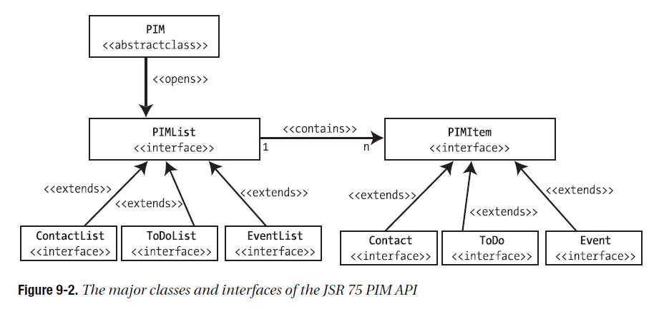
Figure 1. Major classes & Interfaces of the JSR 75 PIM API.
JSR (Java Specification Requests) 75 is a Java API package to handle PIM accesses on Java ME enabled mobile phones.
PIM is a singleton object used to enter the lists and records. PIM represents a database of lists of items or records. Lists and the items are accessed via the interface and PIMItem PIMList interface.
Before using it, should be checked first whether the PIM Optional Package is available on the mobile phone:
String currentVersion = System.getProperty(“microedition.pim.version”);
If the optional package is not available function will return a null value. Until now the existing version is "1.0".
The first step to be able to use the PIM API is to call a static method for PIM to retrieve the singleton instance. PIM instance gives the right to access the PIM lists / databases and PIM items / fields. This is how to use them:
private PIM pim;
pim = PIM.getInstance();
The database can be manipulated after the method openPIMList() is executed. After the database successfully open, the items inside can be accessed as needed. There are two kinds of methods to open the database, namely:
public PIMList openPIMList(int pimListType, int mode) throws PIMException
public PIMList openPIMList(int pimListType, int mode, String name) throws PIMException
JSR 75 can express pimListType as PIM.CONTACT_LIST, PIM.EVENT_LIST, and PIM.TODO-LIST. Next, for the type of access mode it can use one of PIM.READ_ONLY, PIM.READ_WRITE, or PIM.WRITE_ONLY. Open the database by name and type can be done by using the second method of openPIMList(). Items acquired after the database is opened by the following example:
ContactList contactList = (ContactList) pim.openPIMList (PIM.CONTACT_ LIST, PIM.READ_WRITE);
Each record in the list can be accessed through the Enumeration of PIMItems. There are three methods for this, namely:
public Enumeration items () throws PIMException
public Enumeration items (PIMItem matchingItem) throws PIMException
public Enumeration items (String matchingValue) throws PIMException
The second and third methods are commonly used for searching records based on parameters that are passed.
2.2 File Synchronization
File synchronization is a process to ensure that a file is updated each other on two or more locations with special rules. There are two kinds of file synchronization, first is one-way file synchronization and the other one is two-way file synchronization. One-way file synchronization is usually called mirroring. In this type of synchronization updated files are copied from the original site to one or more destinations, but no files to copy them back to their original locations. In contrast, the two-way file synchronization updated files are copied out in both source and destination locations, so that both locations have the exact same data.
2.3 vCard
vCard is a file format standard for storing electronic business card information. Attributes contained in the vCard generally includes name, address, phone number, email address, birthday, also with support for custom fields such as images. vCard is often used to import and export contacts in the phonebook. The PIM API also support this vCard standard. Figure 2 shows the format of vCard.
BEGIN:VCARD
VERSION:3.0
N:Gump;Forrest
FN:Forrest Gump
ORG:Bubba Gump Shrimp Co.
TITLE:Shrimp Man
PHOTO;VALUE=URL;TYPE=GIF:http://www.site.com/dir_photos/my_photo.gif
TEL;TYPE=WORK,VOICE:(111) 555-1212
TEL;TYPE=HOME,VOICE:(404) 555-1212
ADR;TYPE=WORK:;;100 Waters Edge;Baytown;LA;30314;United States of America
LABEL;TYPE=WORK:100 Waters Edge\nBaytown, LA 30314\nUnited States of America
ADR;TYPE=HOME:;;42 Plantation St.;Baytown;LA;30314;United States of America
LABEL;TYPE=HOME:42 Plantation St.\nBaytown, LA 30314\nUnited States of America
EMAIL;TYPE=PREF,INTERNET:forrestgump@example.com
REV:20080424T195243Z
END:VCARD
Figure 2: vCard example
The data used for the application is written in csv (comma separated value) format like the above vCard example.

PREVIOUS WORKS

Microsoft ActiveSync
ActiveSync [5] is a protocol developed by Microsoft in 1996, allowing mobile phone users to synchronize email and calendar besides contacts. It is a proprietary standard that works with Microsoft Exchange clients which are mostly available on smart phones like Windows Phones, iPhone, Android but not on feature phones.

Google Sync
Google Sync [6], announced in 2009, uses the Microsoft ActiveSync protocol to do the same task that is synchronizing PIM (mail, contacts and calendar). It is available also only on smart phones.
The limitations of applying synchronization mechanism to feature phones can be handled by this Java ME’s PIM API enabled application since it is widely available in the market for low end smart phones or feature phones.

IMPLEMENTATION
The programming language used in making this is Java ME applications with the NetBeans IDE 6.9 as the Integrated Development Environment (IDE). Java programming language Java ME was chosen because it is a software platform and one of the most dominant in the feature phones ecosystem today. Java ME also has cross-platform functionality and is quite safe to run on mobile devices. Besides, Java ME has an API to access personal information such as contact through PIM optional package. The use of Java ME allows creation of applications with a Graphical User Interface (GUI).
The implementation also involves a web server hosted with a public IP (Internet Protocol) address in order to store and synchronize contacts to mobiles. The web server is running an Apache with PHP support, and a MySQL database.

Synchronizing Procedure
This process consists of several sections and sub-processes. The first is to create a temporary file procedure, in which the application will create a temporary file to store contacts data that had been downloaded before the synchronization process. This procedure will try to access data on mobile phones’ contacts for the synchronization process. If the access fails, then the application displays an exception that the access is denied. Another procedure is then run to continue the synchronization process. This procedure creates a csv (comma separated value) file that is placed on the memory card slot. This file contains the contacts data that are successfully downloaded by a download from web server function.
Another procedure will open the csv file to do the readings. Data is read per line cut and stored in an array of strings. Then the string array is passed through an add contact procedure when processing is complete for each block. This process is repeated until all data is read out and processed.
In the making of web application part, the language used was HTML, PHP, and CSS to customize the look and design. These languages were chosen because they are open source, reliable, and cross-platform. This flexibility makes it suitable for applications developed with mobile devices.

EVALUATION
Testing is done to see if the process of retrieving the contacts data, the contacts back-up data, and synchronization process are successful. Applications tested on four different mobile phones, the Nokia C6-00, Nokia 5730, Sony Ericsson K660i, Sony Ericsson J210i and Hazel.
Table 1 shows the success rate of installation and synchronization on Java enabled phones. Found one phone which has Java capability but the operational fails due to the JSR 75 package was not available in the phone. BlackBerry phones have Java capability but they are not using the standard PIM as in JSR 75, and application must be built separately using its own SDK (Software Development Kit). Same thing happen to Android phones.
Tests are done from moving contacts list from one phone to another, and deleting all contacts from phone then retrieve everything back from the server.

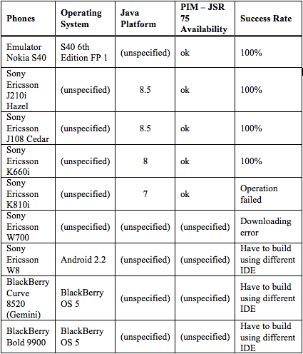
Table 1: Evaluation on mobile phones

Comparison to Google Sync & ActiveSync
Synchronizing with these technologies were found that existing contacts in the mobile phones are synchronized to the server and also to the devices, resulting in redundant contacts both in device and server, filling the contacts with similar entries. It seems that Google Sync and ActiveSync cannot read existing contacts or do not create a temporary table of contacts before the synchronization process.
The PIM standard on JSR 75 has an advantage over the ActiveSync on the choice of field entries on each contact. ActiveSync only synchronizes several phone numbers fields compare to the PIM which has multiple phone numbers fields as well as: address, email, birthday, photo url and notes.

CONCLUSION
Based on the test results, the conclusions are:
The application is only able to retrieve the contacts list stored on the mobile phone memory not on SIM cards.
The success of the back-up data depends on the successful delivery of data and the existence and stability of Internet connections.
Application can run perfectly on the production of Nokia mobile phone with S40 6th Edition operating system and S60 (except in the Nokia E72). This may be because the application fails to access the contact list in an array of PIM database.
Application can also run perfectly on the production of Sony Ericsson mobile phones with Java Platform 8 and up.

REFERENCES
- http://www.oracle.com/technetwork/java/index-jsp-138820.html accessed 23 February 2012.
- Ghosh, Soma. 2009. J2ME Personal Information Management (PIM). http://www.ibm.com/developerworks/ webservices/library/ws-pim/
- http://www.oracle.com/technetwork/java/javame/about-java-me-395899.html accessed 23 February 2012.
- vCard: The Electronic Business Card. 1997. Internet Mail Consortium. http://www.imc.org/pdi/vcardwhite.html
- DiGiacomo, Patricia. 2007. Deploying Exchange ActiveSync in Exchange Server 2007. http://technet.microsoft.com/en-us/library/bb508904(v=exchg.80).aspx
- http://www.google.com/mobile/sync/ accessed 23 February 2012.

