Motivating EFL Learners and Arousing Their Creativity in Reading Class

Henny Putri Saking Wijaya
Petra Christian University, Surabaya

Introduction
As one of language skills, reading plays an important role to help learners acquire more vocabulary and sentence structures. However, most EFL learners see Reading Class as a boring class. They only do reading aloud and reading comprehension exercises in every meeting. On the other hand, EFL teachers often encounter authoritative and resources problems in selecting reading texts other than those prescribed in the course books. Within these limitations, teachers are often led into using repetitive activities which demotivate the learners in Reading Class. This situation not only happens in secondary levels but also in university levels. In English Department, Petra Christian University the materials for Reading Classes have been selected by the subject coordinator. The Reading teachers do not have the freedom to choose the materials. Moreover, the students learn reading skills not as integrated skills. The students take Reading Class for four semesters and they do the same activities for four semesters. Teachers focus more on teaching the basic skills of reading such as skimming, scanning, guessing vocabulary in context by doing the exercises provided in the materials. These conditions make students get bored and they cannot get the importance of reading skills. This paper aims to exploit reading texts in order to generate various interesting activities to not only motivate learners to be engaged in Reading Class but also arouse their creativity.

Why is Reading Class Boring?
Besides the repetitive activities in the materials, there are other reasons why reading class is boring.
- The topic is not interesting for students.
Many reading topics are not interesting for students. They do not have background knowledge related to the topics.
- The materials are too easy or too difficult.
When the materials are too easy, students do not have the challenge to study further. They know all the vocabulary and they think that they get nothing in the class. They can answer the questions easily. On the other hand, when the texts are too difficult, the students also feel bored. It is because there are too many words that they do not know so that they cannot get the idea of the text.
- The teachers and students are passive.
When the teachers are passive, they do not want to think of other activities besides the ones in the books. Students have the book and they can prepare before the class. If the teachers do not prepare other activities, the class will run so slow because the teachers try to prolong the time by explaining things that are out of context. On the other hand, passive students can also make reading class boring. They do not want to participate in the activities. It can be because they do not have the background knowledge related to the topics.

Motivating Learners
In order to motivate learners in Reading Class, there are several points that Reading teachers should consider when designing activities (Harris, 2010, par. 21-28):

- Teamwork
Young people do not like to work alone. By dividing the students into groups, the students can help one another to understand the materials.
- Fun
Learning should be fun. It can be highly emotional.
- Enjoyment of success
Teacher should think of a reward for students who can accomplish the task so that they have the motivation to go forward.
- Active
Students should be active both mentally and physically. The students should produce something as part of the activities.
- Flexibility and creativity
Teachers should be flexible in the instructions so that students can put some of their own creativity into the task.
- Tangible thinking
Teachers should be able to connect ideas, concepts with physical reality.
- Outside the classroom
Teachers should relate the materials with the daily life by preparing students to be aware, asking them to apply the concept after they leave the class.

Proposed Activities
The following activities have been used in Reading Classes for the freshman students in English Department, Petra Christian University.
- Haiku and Poem
The topic of the text is “The Capybara”. Students are asked to bring pictures of animal that they like. Each student brings 2 pictures. Then, they are divided into a group of 3. They are given 2 choices: making 2 haikus or a poem. The pattern of haiku is:
noun (related to the picture)
adjective, adjective
gerund, gerund, gerund
a phrase
noun (representing the picture, the adjectives, the gerunds and the phrase)
Meanwhile, the poem is related to learning reading and the pictures they choose. The first line of the poem is “Learning reading is like…”. The students are given freedom to choose the pictures that they are going to use for either making a haiku or making a poem. The following poem is the students’ work:

Learning reading is like a turtle walking
It is walking slowly but sure
Learning reading is like dolphins swimming
They are swimming enthusiastically
Learning reading is like sheep gathering
They are gathering as they are helping each other
Learning reading is like beach children thinking
They are thinking by looking their surroundings
Learning reading is like cows trying
They are trying their best in giving to others
Learning reading is like a waterfall flowing
It is flowing with no ending

- Making Poster
In this activity, the students read a text about “Save the Jungle – Save the World”. They are assigned to bring a used magazine, scissors and glue. The teacher provides a paper. They are divided into a group of 4 and asked to make a poster related to the theme of the text. The following picture is the poster produced by the students:



- Blogging
There is a material discussing blogging. The teacher gives a piece of paper to all students and asks them to write a blog. In this activity they can express what they think and feel. The teacher gives some questions related to the Reading Class so that they can reflect on what they have learned and the teacher can get some feedbacks. The following pictures are the students’ work:

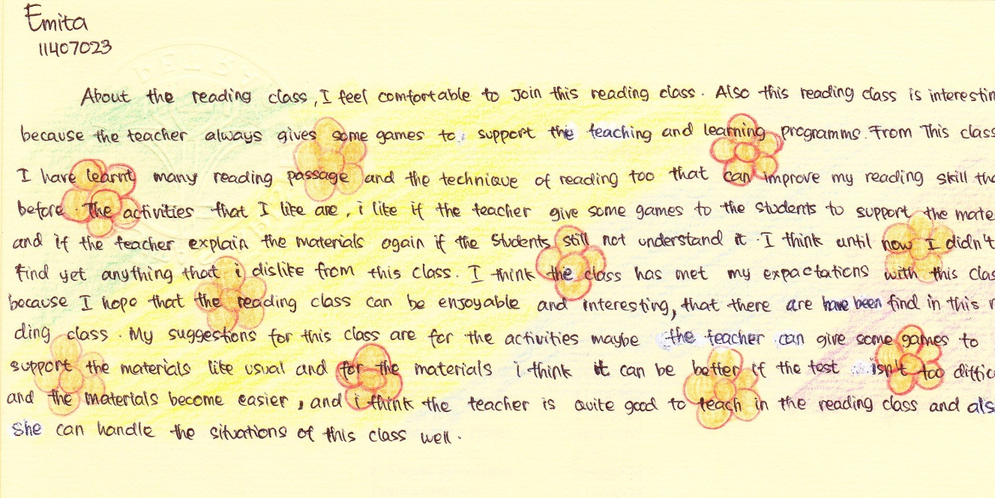

Conclusion
Reading Class can be a very interesting class when Reading teachers can create activities that can encourage students to learn and explore more. These proposed activities can help Reading teachers arouse the students’ creativity by relating the materials with daily lives. Personalizing the texts can be an alternative media to make students participate and have motivation in Reading Classes.

Bibliography
Harris, R. (2010). Some Ideas for Motivating Students. Retrieved from http://www.virtualsalt.com/motivate.htm on November 15, 2011.

