Increasing the output of Solar Cell
Using Double Reflectors
(Domestic Manufacturing: Experience, Challenge, Opportunities)

Murtiyanto S., Thiang, Kharis Tanuwijaya
Petra Christian University
Faculty of Technology, Electrical Engineering
Jalan Siwalankerto 121-131, Surabaya
Email: murtis@petra.ac.id, thiang@petra.ac.id

Abstract

This paper describes research result about improvement solar cell output power using double reflector. Two mirrors are used as the reflectors. The two mirrors are placed on the north and south side of the solar cell. Position of both mirrors are arranged to find the angle of the mirror that provides the most optimal output power of the solar cell. Power measurement was done by measuring open circuit voltage and short circuit current of the solar cell output. Experiments were done by measuring output power of solar cell with variation in angle of both mirrors. Angle of both mirrors is arranged linearly starting from 0° to 90° with step of 10°. Experimental results showed that by using reflectors, output power of solar cell was increased up to 123,93%.

Keywords: solar cell, power, sun energy, reflector

INTRODUCTION

Solar cell converts light into electricity. The amount of the electrical energy as the output of this energy conversion is heavily depends on the intensity of radiation and the area of solar cell.

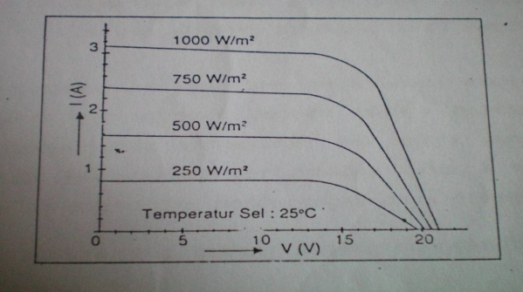
Fig.1 Output of Solar Cell on 25⁰ C
with various irradiance.
Ref: Widiawan, Kriswanto (1994, p.5)

Thus increasing the output of solar cell can be achieved by either exposing the solar cell to higher intensity of radiation or increasing the surface of solar cell which means using more solar cells.

Those two principles brought to the idea of using mirrors as reflectors to collect the radiation that falls outside of the solar cell, and brings it into the surface of the solar cell. This method will combine the two pre-requisite condition of increasing the output of solar cell.

ANGLE OF REFLECTORS.

As the sun travels from East to West, the best position to put the reflectors are on the North and South side of the solar cells, because it can be placed fixed un-changed all the day long.

In this system two mirrors, with the same size of the solar cell, are used to collect the excess radiation outside the solar cell and direct it to the solar cell. One mirror is placed in the North side of the solar cell and the other mirror is placed in the South side.

Seasonal adjustment to the angle of reflectors should be made according to the path of the sun which goes more the North and to the South alternatively, according to the month of the year and the location of the plant.

The angle of each mirror should be adjusted that all the reflected radiation will fall on the entire surface of the solar cell, as shown in Fig.2

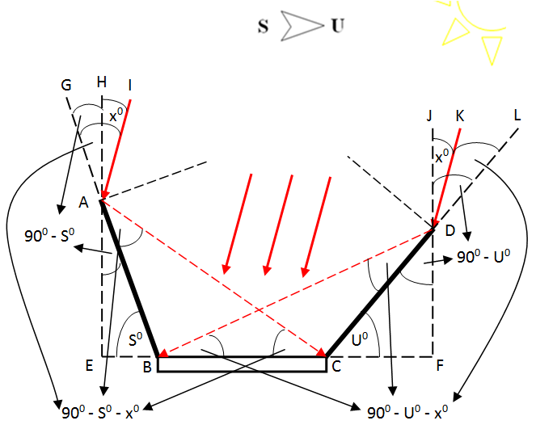

Fig.2. The Angle of Reflectors

By using the principle of reflection, a formula for the angle of each mirror can be derived, as (1) and (2).

$U^{0}=\frac{{180}^{0}-{2x}^{0}}{3}$ (1)
$S^{0}=\frac{{180}^{0}+{2x}^{0}}{3}$ (2)

Where U⁰ is the angle of the North side reflector and S⁰ is the angle of the South side reflector. And x° is the angle of sun’s radiation to vertical line, perpendicular to the earth. (normal to the earth). The value of x° is positive if the radiation comes from the North. On the other hand the value of x° is negative if the radiation comes from the South.

CONTROL SYSTEM

Microcontroller ATMega8 is used to generate output signal to trigger the motor driver that moves the motors of the reflectors to position itself in its correct angle.

There are two option of operation being used in this plant.
- Open loop system, where the angles of the reflectors are calculated based on the input of the date and location of the plant.
- Closed loop system, where the reflectors are moving, looking for the best angle by itself.

Real Time Clock (RTC)
μ-Controller
Output Angle of Reflectors
Input Date & Location
Sensors V_{oc} and I_{sc}
Solar Cell

Fig.3. The Control system

In the open loop system, particular information of date and location of the plant is given to the microcontroller. Then the value of x°, that is the angle of sun’s radiation to the vertical line, perpendicular to the earth. (normal to the earth) can be calculated, and finally using (1) and (2) the angle of reflectors can be calculated. For the time reference of the system, one can use a Real Time Clock (RTC) circuit.

In the closed loop system, Voc and Isc are measured and then it will be used for calculating the power of solar cell. Simple measurement circuit is built for this purpose. These values are then to be used to calculate the Filled Factor (FF) and Maximum Power Point (MPP) of the solar cell, using (3) and (4)

$FF= \frac{V_{OC}-\ln{(V_{OC}+ 0,72)}}{V_{OC}+1}$ (3)
$MPP=V_{OC}×I_{SC}×FF$ (4)

The measurement of Voc and Isc is taken every 10⁰ step while the reflector is moving from 0⁰ to 90⁰. Then the value of FF and MPP are calculated and compared. The position that gives the highest value of MPP is considered as the best angle of the reflector. This process is conducted for each reflector consecutively.

This closed loop system operation is more adaptive to any location and any date of the year. This is the advantage of the closed loop system option.

A relay and signal conditioner circuit, as shown in Fig.4 and Fig.5, are added to the system in order to measure Voc and Isc separately, and match the values to the range of ADC circuit prior to the input of microprocessor.

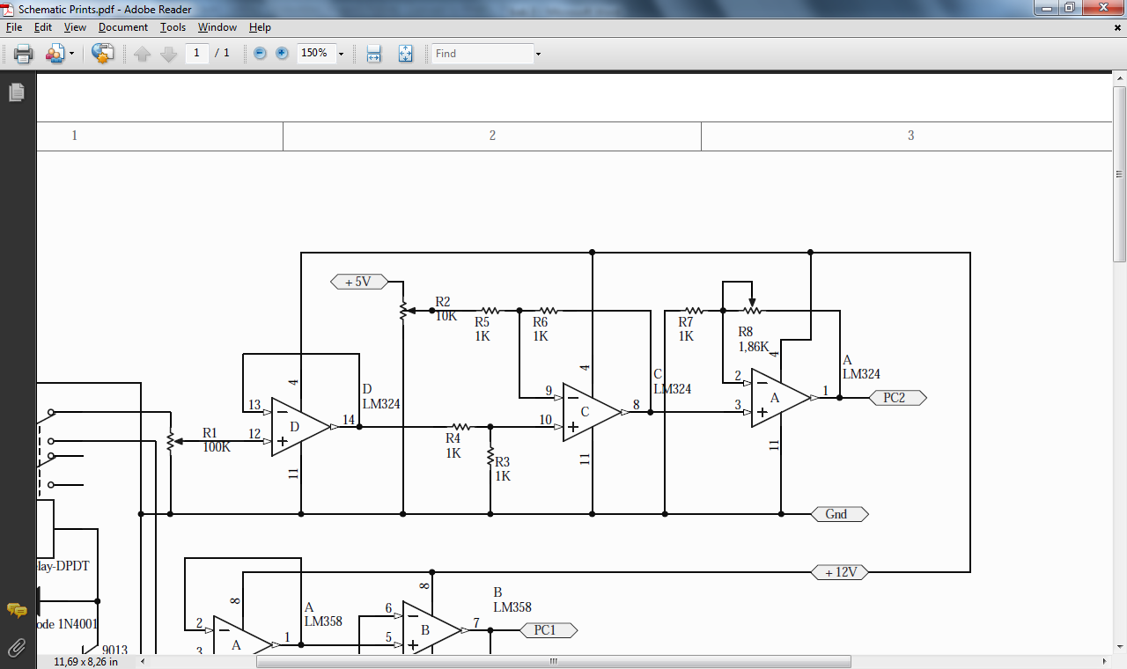

Fig.4.Signal Conditioner for V_{OC}

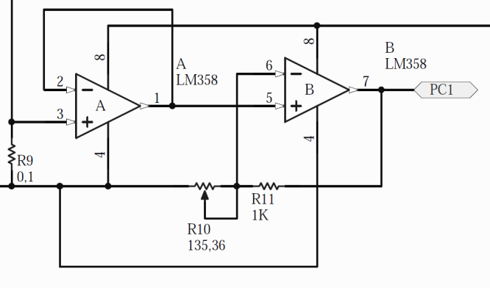

Fig.5.Signal Conditioner for I_{SC}

THE MEASUREMENT

The measurement is conducted for the closed loop system, because we want to know whether the system can choose its angle of the reflector correctly or not.

The measurement was conducted on the flat area at the top roof of J-Building at Petra Christian University, 7.4⁰ South from the equator.

The solar cell used in this project is Poly-crystal Solar Cell from Kyocera – KC 50T made in Japan. It has efficiency of 16%. The size of the solar cell is 63,9 cm x 65,2 cm

The mirrors as reflector has the size of 70 cm x 64 cm for each mirror. There are two mirror of the same size that placed at the North side and at the South side of the solar cell.

The temperature of solar cell is measured using Infrared thermometer, Raytek PM Plus, that has measurement range from -18⁰C until 870⁰C.

The measurement was taken every hour from 9am to 4pm. Initial position for both mirrors are horizontal or 0⁰ degree. Then mirror at the North side was moved every 10⁰ from 0⁰ to 90⁰ while the other mirror stayed at its horizontal or 0⁰ position.
By comparing the result of every 10⁰ change, the North side mirror will be guided to move and stay on its best position. Then the cycle is repeated for the other mirror, the South side mirror.

The result is shown in Table 1, 2 and 3.

Table 1. Measurement at 09.00

Angle N (°) | Angle S (°) | Temp (°C) | V_{OC} (V) | I_{SC} (A) | MPP (W) | Sky
0 | 0 | 41 | 20.1 | 2.26 | 36.74 | bright
10 | 0 | 41 | 20.07 | 2.38 | 38.62 | bright
20 | 0 | 41 | 20.04 | 2.45 | 39.69 | bright
30 | 0 | 41 | 20.01 | 2.45 | 39.61 | bright
40 | 0 | 41 | 19.95 | 2.45 | 39.46 | bright
50 | 0 | 41 | 19.88 | 2.45 | 39.32 | bright
60 | 0 | 41 | 19.95 | 2.66 | 42.85 | bright
70 | 0 | 41 | 20.04 | 2.92 | 47.30 | bright
80 | 0 | 41 | 19.95 | 2.52 | 40.59 | bright
90 | 0 | 41 | 19.88 | 2.52 | 40.44 | bright
70 | 10 | 41 | 19.79 | 2.96 | 47.24 | bright
70 | 20 | 41 | 19.7 | 2.89 | 45.89 | bright
70 | 30 | 41 | 19.67 | 2.92 | 46.28 | bright
70 | 40 | 41 | 19.64 | 2.92 | 46.19 | bright
70 | 50 | 41 | 19.67 | 3.08 | 48.81 | bright
70 | 60 | 41 | 19.51 | 2.94 | 46.15 | bright
70 | 70 | 41 | 19.4 | 2.85 | 44.65 | bright
70 | 80 | 41 | 19.42 | 1.69 | 26.38 | bright
70 | 90 | 41 | 19.2 | 1.18 | 18.18 | Bright

Table 2. Measurement at 12.00 noon

Angle N (°) | Angle S (°) | Temp (°C) | V_{OC} (V) | I_{SC} (A) | MPP (W) | Sky
0 | 0 | 50 | 19.73 | 2.73 | 43.40 | Bright
10 | 0 | 50 | 19.7 | 2.78 | 44.14 | Bright
20 | 0 | 50 | 19.67 | 2.8 | 44.38 | bright
30 | 0 | 50 | 19.64 | 2.82 | 44.61 | bright
40 | 0 | 50 | 19.64 | 2.8 | 44.29 | bright
50 | 0 | 50 | 19.64 | 2.87 | 45.40 | bright
60 | 0 | 50 | 19.76 | 3.32 | 52.88 | bright
70 | 0 | 50 | 19.7 | 2.96 | 47.00 | bright
80 | 0 | 50 | 19.6 | 2.89 | 45.63 | bright
90 | 0 | 50 | 19.4 | 2.8 | 43.87 | bright
60 | 10 | 50 | 19.4 | 3.13 | 49.04 | bright
60 | 20 | 50 | 19.4 | 3.18 | 49.83 | bright
60 | 30 | 50 | 19.42 | 3.2 | 49.95 | bright
60 | 40 | 50 | 19.42 | 3.2 | 49.95 | bright
60 | 50 | 50 | 19.4 | 3.55 | 55.62 | bright
60 | 60 | 50 | 19.45 | 3.27 | 51.14 | bright
60 | 70 | 50 | 19.36 | 3.18 | 49.44 | bright
60 | 80 | 50 | 19.29 | 2.85 | 44.17 | bright
60 | 90 | 50 | 19 | 1.69 | 25.84 | bright

Table 3. Summary of the whole measurements

Time | W/O Reflector  MPP (W) | With Reflector |  |  | Increase MPP
Time | W/O Reflector  MPP (W) | Angle N (°) | Angle S (°) | MPP (W) | Increase MPP
09.00 | 36.74 | 70 | 50 | 48.81 | 132.85%
10.00 | 43.62 | 70 | 50 | 60.29 | 138.22%
11.00 | 35.41 | 70 | 60 | 47.83 | 135.07%
12.00 | 43.40 | 60 | 50 | 55.62 | 128.16%
13.00 | 42.23 | 70 | 50 | 49.91 | 118.19%
14.00 | 31.18 | 60 | 50 | 33.52 | 107.50%
15.00 | 21.41 | 70 | 40 | 22.34 | 104.34%
16.00 | 5.53 | 90 | 40 | 7.03 | 127.12%
Average increase of MPP |  |  |  |  | 123,93%

From the result, it can be seen that the system is quit good to find a correct angle during the day time. It failed once at 16.00. However in the real operation, the system doesn’t need to find the best angle of reflector every hour. It can be scheduled that the system does a correction of the angle of reflectors once a day or once a week.

At the date of measurement the best angle of North side Reflector lies between 60⁰ to 70⁰ while the best angle for the South side reflectors are within 40⁰ to 60⁰

The highest increase happened around 10am to 11am, with an increase about 35%.

CONCLUSION

Double reflectors using common mirror as explained in this article has proved that it is able to increase the output of solar cell.

This method is relatively cheap and suitable for a country such Indonesia where there is no solar cell factory in the country. Yet the output of a solar cell can be increased by using mirrors.

The measurement has neglected the effect of un-equal intensity of radiation on the surface of the solar cell. Because the solar cell is placed fixed horizontally, therefore during the morning and late afternoon the reflected sun-shine won’t fall at the whole surface of the solar cell completely. This phenomena is logically true when we saw the result of measurement.

By using this system which can be produced locally, one can increase the output of solar cell up to 23,93%.

REFERENCES

- Atmel Corporation, “ATMega8” Atmel Product Datasheets.2009. 24 September 2009. <http://www.atmel.com/dyn/resources/ prod_documents/doc2486.pdf>
- Bowden, Stuart and Christiana Honsberg . “Fill Factor” Photovoltaic CDROM. n.d.. 6 January 2010. < http://pvcdrom.pveducation. org/>
- Merrick, David. Energy Present & Future Options (vol.2). Norwich: John Wiley & Sons, 1984
- Patel, Mukund R.. Wind and Solar Power Systems (2nd ed.). Boca Raton: Taylor & Francis Group, 2006.
- Pidwirny, Michael. “Earth-Sun Geometry” Fundamental of Physical Geography (2nd ed.). n.d.. 7 November 2009. <http://www. physicalgeography.net/home.html>
- Tandijono, Rudy Saputra. Tracking Max Power Point Solar Cell dan Distribusi Daya Menggunakan Microcontroller AT Mega 16. (TA-S1 No. 02010855/ELK/2008). Un-publish undergraduate thesis, Surabaya: Universitas Kristen Petra, 2008.
- Wibowo, Hariyanto. Studi Penggunaan Solar Reflector Untuk Optimalisasi Output Daya Pada Photovoltaic (PV) Module. (TA-S1 No. 01010609/ELK/2009). Unpublish undergraduate thesis, Surabaya: Universitas Kristen Petra, 2009

